Science in Golden Cheetah
Wherever possible we choose to use published science. Science that has been developed with the academic rigour demanded by the scientific method; evidence based, peer-reviewed and original. This means we are able to provide the best analysis available, but at the cost of a steep learning curve for new users. So below, we try to introduce some of the most important concepts, why they are important and how they might help you to improve.
Power and Duration - Critical Power and W’
How hard can you go, in watts, for half an hour is going to be very different to how hard you can go for say, 20 seconds. Then thinking about how hard you can go for a very long time will be different again. When it comes to reviewing and tracking changes in your performance and planning future workouts you quickly realise how useful it is to have a good understanding of your own limits.
In 1965 two scientists Monod and Scherrer presented a ‘Critical Power Model’ where the Critical Power of a muscle is defined as ‘the maximum rate of work that it can keep up for a very long time without fatigue’. They also proposed an ‘energy store’ (later to be termed W’) that represented a finite amount of work that could be done above that Critical Power.
work
The Critical Power Model
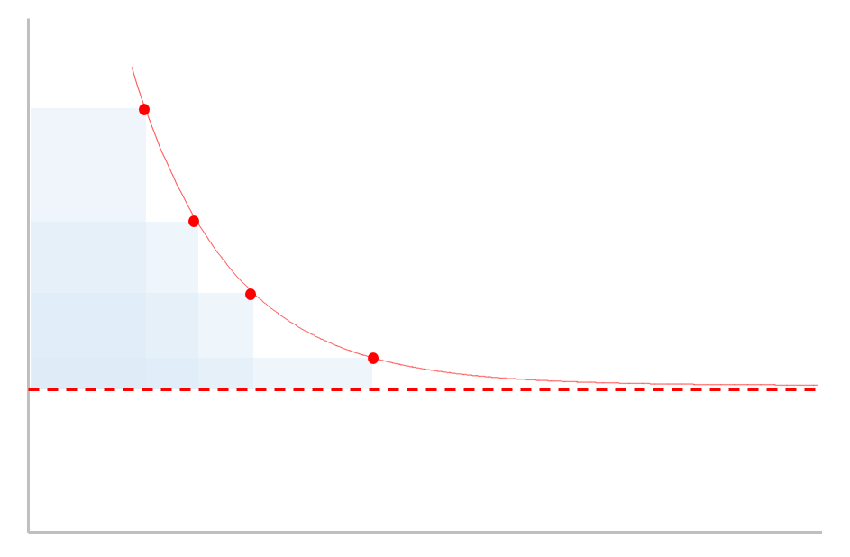
In cycling parlance W’ would be referred to as the matchbook– the harder you go the quicker it will be used up, but temper your efforts and you can ‘save a match’ for the last sprint. CP, on the other hand, is that intensity (or power output) where you are uncomfortable but stable, akin to your TT pace. You know that if you try to go any harder you are gonna blow up pretty quickly.
CP
time
W’
Monod and Scherrer also provided a mathematical formula to estimate the maximum power you can go for any given duration using W’ and CP as parameters. This formula is pretty reliable for durations between 2 minutes and an hour or so, but less reliable for shorter and longer durations. So, over the last 50 years, variations of these models have been developed to address this, and it still continues to be a topic of great scientific interest.
We have implemented some of these models so you can get power estimates to predict and review your training and racing. We have also implemented a wholly new model based ‘Extended CP model’ that is based upon bioenergetics.
Bioenergetics
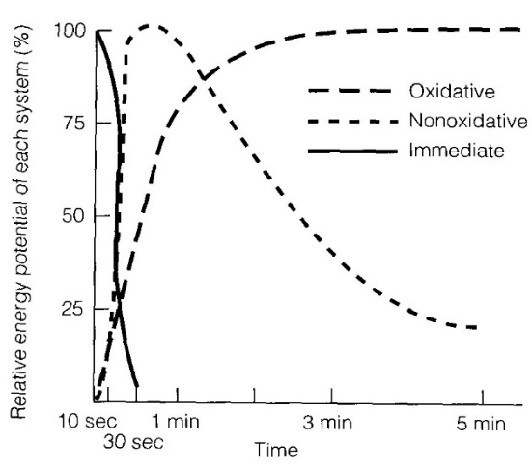
We use complex sources of overlapping energy when we exercise. These energy sources are anaerobic with a limited capacity and a high rate limit (like W’) and aerobic with an unlimited capacity but a low rate limit (like CP).
Anaerobic Systems In the first 10 seconds or so of high output work we draw upon energy stored within the muscles that have immediate availability – so we can sprint all out for 10-30 seconds without drawing breath and at very high work rates. These chemicals are phosphates called ATP (adenosine triphosphate) and PCr (phosphorcreatine). Interestingly, after about 3 minutes of total rest these stores are largely replenished.
So for the next 50 seconds or so after those phosphates are depleted we primarily get our energy from glycolysis and still without drawing breath. This is the conversion of glucose into lactate. It takes us about 1 hr to recover and remove all the lactic acid produced, but most of it is gone after about 10 minutes – and we can speed up this clearance through light exercise – which is why a warm-down is a good idea after intense exercise.
Aerobic Systems But now, sadly, after that all-out minute we are going to have to draw breath, because we need the oxygen to power the aerobic energy systems. First up we get aerobic glycolysis, this is converting glucose into pyruvate by burning it with oxygen in a really complicated 10 stage cycle. The conversion rate is limited by the amount of oxygen the lungs can absorb (vo2max) and the available fuels. It can take anywhere between 1-3 minutes to get up to ‘peak’ production and then dies away slowly over time. Once all the glucose is gone, we will bonk, which is why gels and powders are high in easily digested glucose – to refuel this process. Lastly, from about 6-7 minutes we start to rely upon lipolysis that utilises an almost limitless source of energy; fat and water. So stay hydrated !
The Future of Power-Duration models
Our Extended Power Duration Model extracts the likely contribution of these energy systems to predict the energy production (or watts per second). This is akin to reading the fuel gauge to work out how fast you’re going in a car. It’s not an exact science and so yields an approximated answer, which can be slightly overestimated because it doesn’t really consider why we fatigue.
It is likely that in the next 2-3 years current research will help to explain muscular, neural and psychological fatigue or constraints. These in turn can be used to refine our models. Research is also likely to expand our understanding of W’ and CP and how they reflect underlying physiology and associated dynamics (maybe even CP fluctuates depending upon how we ride).
Slow and Fast-twitch Muscles
Roughly 40% of your body weight is muscle; skeletal muscle that’s attached to your bones via tendons and are controlled via conscious thought (“shut up legs, pedal faster”), but also smooth muscle including arteries, the bladder, eye and reproductive organs and of course cardiac muscle pumping blood 24x7 and again without any conscious thought.
We’re going to focus on skeletal muscle. Our legs contain lots of different muscle groups; the quadriceps, hamstrings, calves etc. These muscle groups work together when we walk, run, kick and jump. Each muscle group in turn is comprised of a large number of motor units (MU) that in turn contain a motor neuron and a collection of muscle fibres. Our brain triggers a muscle group into action by recruiting as many of its motor units as needed to meet the force we want. It does this by firing the motor neurons that sends an electrical pulse to the muscle fibres causing them to contract.
The force that a muscle fibre contracts is known as twitchiness; we have type I known as slow-twitch fibres that don’t contract with much force but can keep doing it for a long time and a type II also known as fast-twitch that can be very powerful, but fatigue much more quickly. In healthy adults the distribution of type I/II differs significantly by muscle group and also to a lesser extent upon your genetics. Further, type II fibers are either type IIa that can use aerobic and anaerobic energy or stronger type IIb that will only use anaerobic.
With training we can increase our overall muscle mass and can also convert some of our fast-twitch to slow-twitch fibres to improve endurance performance but at the cost of a loss of strength.
Recruitment and Central and Peripheral Muscle Fatigue
As we increase the power we want to generate our brains will recruit more and more of the motor units to meet the demand. As the demand gets higher we reach a point where all motor units available will be firing. When fresh and all motor units are available we will hit our P-max power, but if we’re fatigued some of those muscles will be exhausted and unavailable – and our maximum power will be reduced. This peripheral fatigue occurs much earlier for fast-twitch than slow-twitch muscles. So our brain will always recruit from slow-twitch before fast-twitch muscles to meet demand – so the fast twitchers are saved for when we really need them.
Aside from fatigue within the muscle fibres, our brains and neurons will also limit what we can achieve; in some cases this keeps us well within our natural capabilities, perhaps as a ‘safety mechanism’. And there is lots of research being done into this central fatigue to see how if differs by individual and how much it can be changed with training and the right ‘motivation’.
Lactate Threshold
Now remember that pyruvate we created earlier when our muscles were burning glucose, it can go in two directions, a kind of ‘fork in the road’; either it is shuttled back into muscle cells and used as fuel (good) or if they’re not available, it is converted to lactic acid (bad). Initially our blood flow will clear lactic acid away as it is produced to the liver, heart, kidneys where it is slowly converted and stored as fuel for re-use (its more complicated than that, but lets not worry about it here).
As we work a little harder lactate will be created a bit faster, but at the same time blood flow increases our heartrate goes up so we keep clearing it. But eventually we get to a point where lactate levels increase above the baseline (typically 1mmol above), this point is known as “LT1”. At this point we will feel that we are working, but no more than a tempo pace. As we continue to go harder, blood lactate accumulation will increase and so will blood flow as our heart rate rises. We will eventually get to a tipping point where clearance and accumulation will be at a maximum point we can sustain; this is the intensity that best relates to a TT pace and is called “LT2” or more technically the maximal lactate steady state (MLSS). The intensity / power at this point has been shown to be closely related to FTP and CP (although CP is typically a bit higher).
From here if we go harder then we will eventually crash and burn as we hit our maximum HR and can’t get enough oxygen in, let alone clear the acid that’s burning in our legs. These are the higher intensities related to W’.
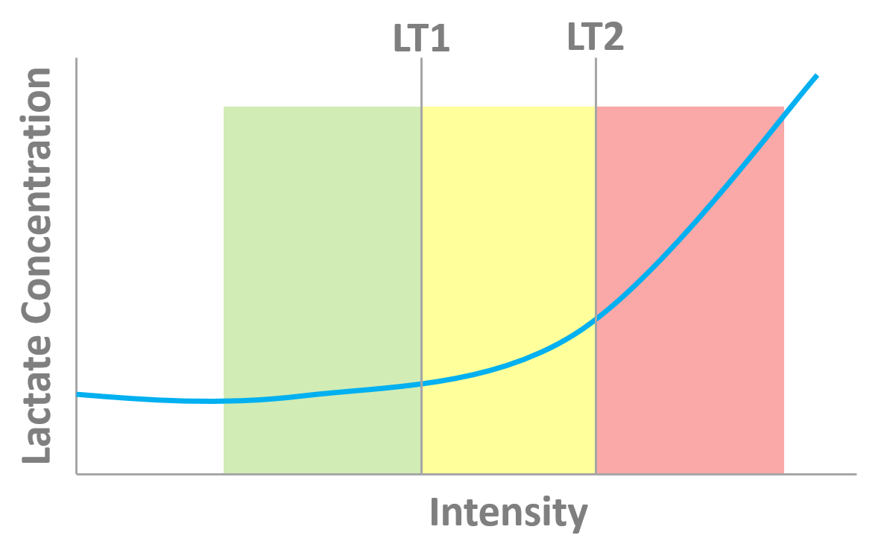Shifting the curve to the right So, if we can shift the blood lactate curve to the right we can exercise harder for longer and make it mentally easier to exercise at mid-range intensities. Looking back at the pyruvate ‘fork in the road’, we need to train our bodies to burn less glucose for fuel and get better at shuttling pyruvate into muscle cells before resorting to producing lactic acid at all.
Our slow-twitch muscle fibres have high volumes of cellular ‘power plants’ called mitochondria these are the destinations for that pyruvate; the more we have the greater capacity we have to re-use pyruvate and less lactate will be produced.
Secondly, fat metabolism doesn’t create lactic acid at all, so the greater power we can develop solely from this (again using our slow-twitch muscles) the less reliance we will have on glucose energy and lactate clearance.
So, training interventions that increase the volume and density of slow-twitch fibres and mitochondria will shift that curve to the right and improve endurance performance. Power at LT2 (CP/FTP) are therefore good indicators of endurance performance.
Matches and Pacing – W’_{bal}
Unless we’re riding the pursuit or a very flat time trial, when we train and race we tend to ride sustained efforts interspersed with recovery. These intermittent bouts might occur when we climb a hill, or sprint out of a corner or bridge a gap. In fact almost all training and racing away from the turbo tends to be variable because of this.
Now, we know from the Critical Power model that when we work above CP we start eating into our limited W’ stores. If we keep going hard enough for long enough we will blow when it’s all gone. But, we also know that it will also be replenished over time too.
W’_{bal} in an evenly paced 2x20 Workout
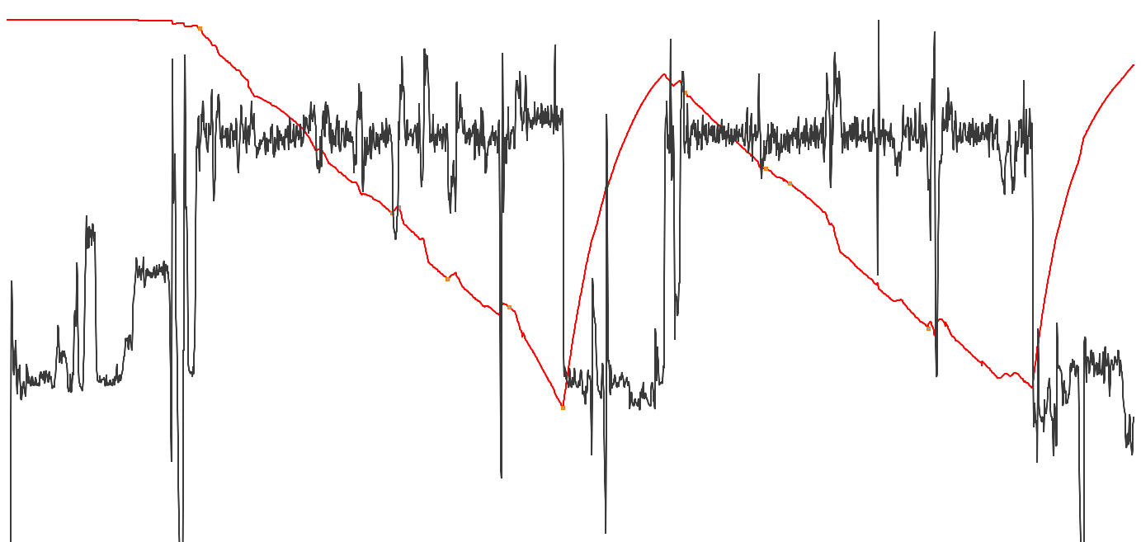
When we work below CP the energy stores within the muscles are restocked. The further below CP we are the faster we will recover, and for the first 30 seconds of recovery we get the most bang for buck as blood-flow into the muscles is still high from the previous bout
Dr Skiba provided a formula for tracking the levels of W’, called W’_{bal} that we can plot alongside power.
It is particularly useful for assessing workouts for likely failure and reviewing and comparing intervals within a single workout, even when they are of differing durations.
It is likely that in the near future you will see W’_{bal} appear on bike computer headunits to show you the capacity remaining as you race.

Analysing Power Data – Average, xPower and NP
When you first start using a power meter you notice that power tends to move around a lot more than, say, your heart-rate.
When you stop pedalling power drops to zero immediately, but HR may take 30 seconds or so to recover. In truth, although the power meter says zero watts when you stop, the body’s physiological response continues for roughly 30 seconds, as HR drops, breathing recovers and more complex energy system processes continue.
This means that if we want to use power output as a measure of training stress we will also need to translate those simplistic power readings into something that reflects the associated physiological processes and their half-lives.
This is what Dr Andrew Coggan’s Normalised Power and Dr Phil Skiba’s xPower are doing; they ‘smooth out’ the power data to reflect the underlying physiological processes. Whilst the underlying assumptions and maths differ slightly they both yield a power output that will reflect the stress of the variable power values more accurately than just taking a simple average.
Skiba/Literature Coggan/TrainingPeaks
Variability Index | Variability Index
Relative Intensity | Intensity Factor
xPower | Normalised Power
BikeScore  Critical Power  W’  W’_{bal} | Training Stress Score  Functional Threshold Power  Functional Reserve Capacity  dFRC

Quantifying Stress – Work, Intensity, TSS and TISS
Given that work in joules can be calculated by multiplying power by time it is very tempting to use this to measure the stress of a ride. But as we get stronger and more efficient those joules become easier to produce, and thus the training stress accrued in the workout should reflect that.
To account for this we need some kind of score that takes into account how hard the ride is based upon our current capability. This is precisely what BikeScore and TSS do. They reflect the stress by taking into account the relative intensity of the workout. This intensity factor is computed as a ratio of the xPower to our current CP. This intensity is then multiplied by the ride duration to get an overall stress score; the higher the stress score the bigger impact it will have had and likely the more recovery we will need the day after.
But there is still a problem, we know that work at high intensities for short durations elicits a different strain to work at low intensities for longer durations and there comes a point where more pain will give little gain. To counter this Dr Skiba introduced Ae and An TISS that are weighted differently for low and high intensity work and allow us to track these training stresses separately.

